Uranium price analysis workflow
Purpose: compare physical investment demand, changes in expected uranium supply and nuclear activity as explanations for monthly uranium price changes. The best-performing measured factor was Sprott purchases. This guide follows the simplified notebook in order and retains our 23-month evaluation period.
Initially, I loaded the monthly IMF commodity price for uranium, extracted the prices and identified the largest movers. Then, I plotted a few major events that may affect uranium price and compared the price around that event. We can see that there are dramatic rises and falls with changes in production, e.g., due to COVID or the Fukushima Daiichi accident. I stopped there as I found there was a huge variability in quantifying how world events affect price (SEARCH FOR #END OF INITIAL APPROACH on the Uranium_price_factors_simplified.asciidoc file), so I simplified the code to consider three main factors:
- Physical investment demand: I used Sprott’s monthly uranium purchases to track demand as more buying may put upward pressure on prices.
- Supply expectations: I used announced increases or cuts to expected production as lower expected supply may push prices up and higher expected supply may push them down.
- Nuclear demand: I used a measure of nuclear electricity generation or operating reactor capacity as greater nuclear activity may increase uranium requirements.

Starting point
Use the IMF data to create a table with a monthly date index and a price column. Use the Sprott extraction cell that creates sprott_monthly, with a monthly date index and sprott_purchases_mlb. The latter measures physical purchases in million pounds of U3O8, not Sprott’s share price. Run the segments below in order after those cells. Code segments form one sequence; the CSV is placed beside the notebook.
These names identify the tables and columns used by the simplified notebook; they are not separate economic concepts.
Name | What it contains
uranium | IMF monthly uranium prices. The price column is in US dollars per pound.
sprott_monthly | A monthly table created by summing Sprott’s reported daily physical purchases.
sprott_purchases_mlb | A column containing purchases in million pounds of U3O8. A value of 1.2 means 1,200,000 pounds.
analysis | Our main table: prices, monthly price changes and all factor measurements aligned by month.
monthly_supply | Current-year and future-year revisions in expected annual production, in million pounds.
generation | Total monthly nuclear electricity generation in the fixed group, measured in TWh.
models | A dictionary specifying which factor columns each regression uses.
MAE | Mean Absolute Error - This is the average size of the errors, ignoring whether the model estimated too high or too low
RMSE | Root Mean Squared Error - RMSE squares the errors, averages them, then takes the square root. This gives greater weight to large mistakes
backtest and scores | The monthly estimates and the MAE and RMSE summaries used to compare models.

Units: lb means pounds of mass; mlb in our column names means million pounds. U3O8 is uranium oxide. TWh means terawatt-hours of electricity. Sprott purchases are quantities of uranium, not share prices or dollars spent.

1 Create one monthly analysis table
Let’s look at percentage changes as price movements. A monthly index aligns all sources to the IMF frequency. Joining on dates matches observations correctly.
Interpretation: a change from $80 to $84 is 5%. Using changes reduces the risk of confusing shared trends in price levels with a useful relationship. Same-month inputs support retrospective comparison; they are not all available before a month begins.

import numpy as np
import pandas as pd
import matplotlib.pyplot as plt
analysis = uranium[["price"]].copy().asfreq("MS")
analysis["price_change_pct"] = (
analysis["price"].pct_change(fill_method=None) * 100
)
analysis = analysis.join(
sprott_monthly[["sprott_purchases_mlb"]], how="inner"
)
analysis = analysis.loc["2021-08-01":"2026-06-01"]
print("Months:", len(analysis))

Why this period?
August 2021–June 2026 supplies 59 shared monthly observations. We excluded Sprott’s launch month and the final month of the acquired chart to avoid partial coverage.
Then we check if price changes and purchases occurred in the same month (same-month purchases) against price changes in one month and purchases from the previous month (previous-month purchases). We did this as a way to describe price changes.
What does same-month mean?
For January’s price change, the same-month model uses January’s purchases. The previous-month comparison instead uses December’s purchases. Both timing checks used 58 matched months; introducing the one-month delay removes the first observation.
The same-month correlation was 0.323, a modest positive relationship. The previous-month correlation was −0.042, approximately zero. We therefore retained same-month purchases for describing price changes. This does not show whether buying came before rising prices: both may respond to the same market conditions.
We selected this timing after examining the data, so it is exploratory. The result does not establish that December purchases predict January price movements.
The final model comparison uses all 59 months, with the first 36 for initial training and the last 23 for evaluation.

Purchase timing and correlation results
Table 1 summarises the exploratory timing checks and yearly same-month correlations. A positive value means higher purchases tended to accompany higher price changes; it does not establish causation.
Comparison | Months | Correlation
Same-month purchases and price change | 58 | 0.323
Previous-month purchases and current price change | 58 | −0.042
2021 same month | 5 | 0.158
2022 same month | 12 | 0.704
2023 same month | 12 | 0.043
2024 same month | 12 | 0.465
2025 same month | 12 | 0.493
2026 same month | 6 | 0.922

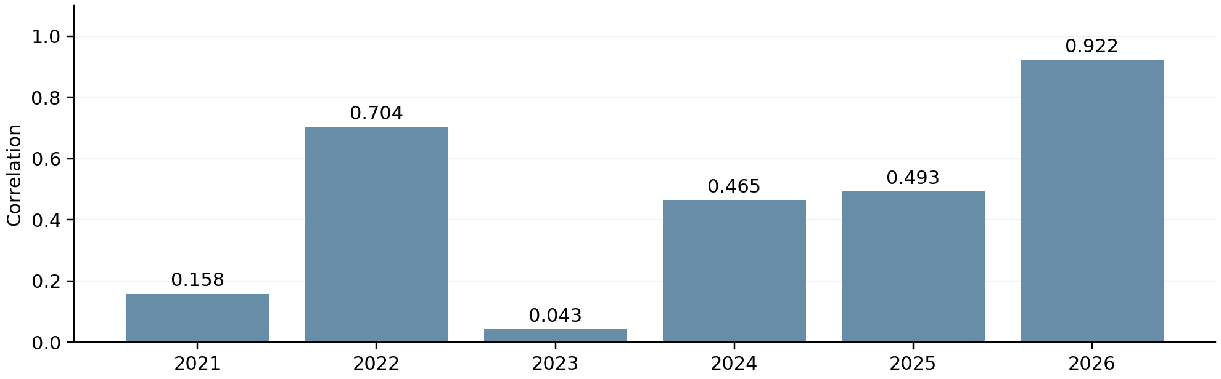
Figure 2 Yearly same-month correlations. The relationship varies across years. The 2021 and 2026 estimates use partial years, and all yearly samples are small.
These results motivated the same-month specification. They are retained as context, while the simplified workflow avoids rerunning the exploratory correlation cells.

2 Add changes in expected supply
Why guidance?
A forecast revision captures a change in expected supply, which may matter before actual output changes. Actual production growth can be anticipated already. We collected both changes and unchanged guidance to avoid selecting announcements only because prices subsequently moved.
Why physical volumes?
Percentages cannot be added across differently sized operations. We convert forecast midpoints (old_mid, new_mid) to million pounds of U3O8 and sum the volume changes. Current-year and future-year revisions stay separate because their timing differs.
supply = pd.read_csv(
"uranium_supply_announcements_2021_2026.csv",
parse_dates=["announcement_date"]
)
supply = supply.loc[
supply["announcement_type"].isin(["cut", "increase"])
].copy()
old_mid = (supply["old_low"] + supply["old_high"]) / 2
new_mid = (supply["new_low"] + supply["new_high"]) / 2
conversion = supply["unit"].map({
"tU": 0.0025998, "million lb U3O8": 1.0
})
if conversion.isna().any():
raise ValueError("Unrecognised supply unit.")
supply["revision_mlb"] = (new_mid - old_mid) * conversion
supply["month"] = (
supply["announcement_date"].dt.to_period("M").dt.to_timestamp()
)
supply["horizon"] = np.where(
supply["production_year"] == supply["announcement_date"].dt.year,
"supply_current_year_mlb", "supply_future_year_mlb"
)
supply_columns = [
"supply_current_year_mlb", "supply_future_year_mlb"
]
monthly_supply = (
supply.pivot_table(index="month", columns="horizon",
values="revision_mlb", aggfunc="sum")
.reindex(columns=supply_columns)
.reindex(analysis.index).fillna(0)
)
analysis[supply_columns] = monthly_supply[supply_columns]
Why announcement dates>
They identify when the information was released, rather than when the forecast production will occur. Monthly data cannot isolate individual announcements made within the same month. Direct column assignment keeps this cell safe to rerun without duplicate columns.
Interpretation: negative means less expected annual supply; positive means more. Zero means no net numerical revision in our collected records, not an absence of all supply news. Warnings without a number and licensed-capacity changes were excluded from the numerical measure. Range midpoints and upper limits are approximations, and a revision may have been anticipated by investors.

Monthly supply revision results
Table 2 records net changes in expected annual production in months containing numerical revisions. Negative values mean less supply than previously planned, not negative physical production. Values are rounded to two decimals.

Announcement month | Current year  million lb | Future year  million lb
November 2021 | −2.08 | 0.00
July 2022 | 0.00 | 0.00
February 2023 | 0.00 | +7.50
September 2023 | −2.70 | 0.00
February 2024 | −9.10 | 0.00
August 2024 | +3.25 | −13.65
November 2024 | +1.00 | 0.00
August 2025 | −3.50 | 0.00

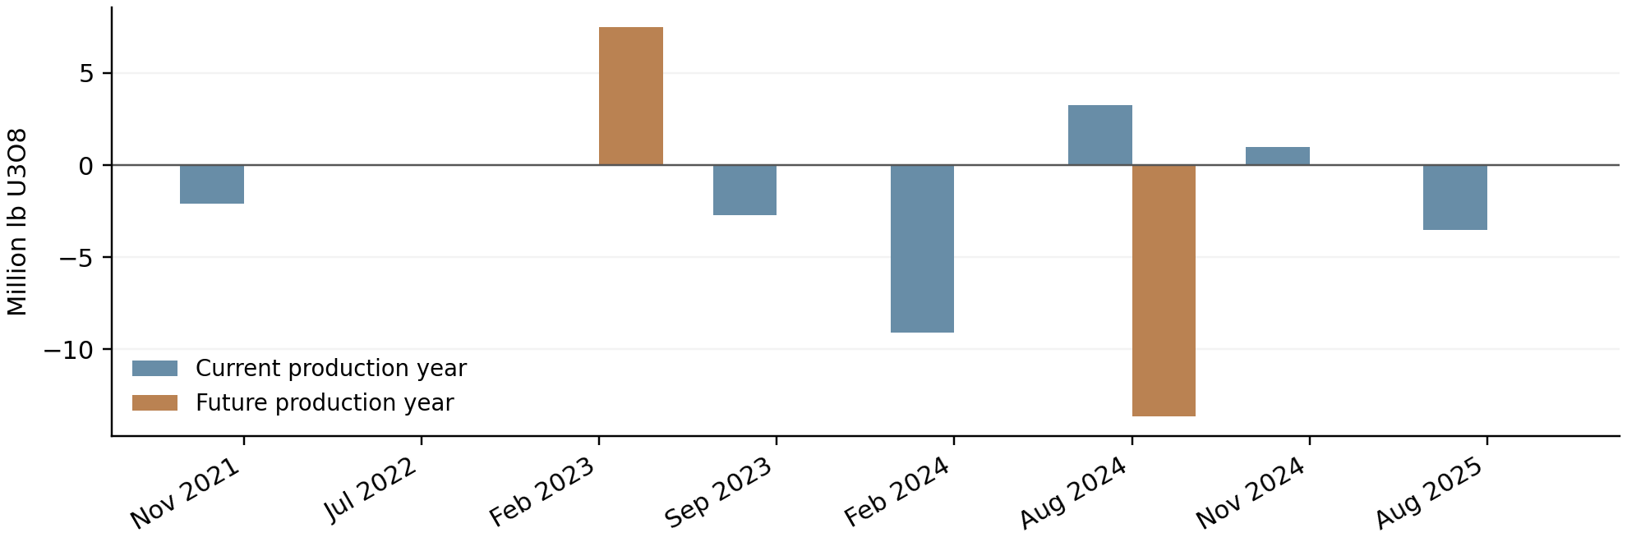
Figure 3 Numerical supply revisions grouped by announcement month and production horizon. Only the eight recorded revision months are shown; this is not a plot of monthly uranium production.
July 2022 nets to zero because a 3 million lb increase at Cigar Lake offset a 3 million lb cut at McArthur River and Key Lake. August 2024 contained both increased current-year guidance and reduced following-year plans. The model kept those horizons separate.

3 Add a nuclear demand proxy
Why generation?
Nuclear electricity production is an observable measure of reactor activity. It is an indirect demand proxy because utilities buy uranium ahead of use. We selected individual countries or economies and excluded regional totals to avoid double counting.

Why complete coverage?
Summing a changing set of countries could create false growth. We retain a fixed group with all monthly values. An extra year of data allows comparison with the same month one year earlier, reducing seasonality. Recorded zeros remain valid, including after reactor closures; missing data are not changed to zeros.
ember_url = (
"https://files.ember-energy.org/public-downloads/"
"generation/outputs/release_generation_monthly_global.csv"
)
electricity = pd.read_csv(ember_url, low_memory=False)
nuclear = electricity.loc[
electricity["Electricity source"].astype(str).str.strip().eq("Nuclear")
& electricity["Area type"].astype(str).str.strip()
.eq("Country or economy"),
["Area", "Date", "Generation (TWh)"]
].copy()
nuclear["Date"] = (
pd.to_datetime(nuclear["Date"]).dt.to_period("M").dt.to_timestamp()
)
nuclear["Generation (TWh)"] = pd.to_numeric(
nuclear["Generation (TWh)"], errors="raise"
)
required_months = pd.date_range("2020-08-01", "2026-06-01", freq="MS")
nuclear = nuclear.loc[nuclear["Date"].isin(required_months)]
nuclear_by_country = nuclear.pivot(
index="Date", columns="Area", values="Generation (TWh)"
).reindex(required_months)
keep = (
nuclear_by_country.notna().all()
& nuclear_by_country.gt(0).any()
)
covered = nuclear_by_country.loc[:, keep]
if covered.empty:
raise ValueError("No countries have complete nuclear data.")
generation = covered.sum(axis=1, min_count=covered.shape[1])
analysis["nuclear_generation_yoy_pct"] = (
generation.pct_change(periods=12, fill_method=None) * 100
)
print("Countries/economies included:", covered.shape[1])
The analysis used 28 countries or economies. Ukraine, Switzerland and Pakistan had missing months and were excluded. This is generation in the covered group, not the full world total. A 5% generation increase does not imply a 5% rise in uranium purchases.

4 Check the table and define comparisons
Every model should use the same months and complete inputs. Otherwise, a change in error could reflect a different sample rather than a better factor.
factor_columns = [
"sprott_purchases_mlb", "supply_current_year_mlb",
"supply_future_year_mlb", "nuclear_generation_yoy_pct"
]
analysis = analysis.sort_index()
expected_months = pd.date_range("2021-08-01", "2026-06-01", freq="MS")
if not analysis.index.equals(expected_months):
raise ValueError("The analysis must cover all 59 agreed months.")
if analysis[["price_change_pct"] + factor_columns].isna().any().any():
raise ValueError("Missing values found in the analysis table.")
print("Months:", len(analysis))
sprott = ["sprott_purchases_mlb"]
supply = ["supply_current_year_mlb", "supply_future_year_mlb"]
nuclear = ["nuclear_generation_yoy_pct"]
models = {
"Historical average": [],
"Sprott only": sprott,
"Supply only": supply,
"Sprott + supply": sprott + supply,
"Nuclear only": nuclear,
"Sprott + nuclear": sprott + nuclear
}

Now this is complete, we can perform a linear regression. For example, factor one (Sprott purchases and price) has a linear positive relationship for the same-month correlation. This means we can produce a line of best fit (regression line) by minimizing the sum of the squared vertical distance (called residuals) between each data point. Then we use R-squared (the coefficient of determination) to measure the proportion of total variance in the dependent variable that is explained by the independent variable ranging from 0 to 1 (0 % to 100 %).

Why linear regression?
A small linear model gives a transparent first comparison. It estimates monthly price change from an intercept plus coefficients multiplied by the chosen factors. Separate models show whether each broad factor is useful alone and whether it adds information beyond Sprott. Both supply columns are treated together as one supply group.
We did not add many lags, interactions or complex algorithms because the dataset is small and the aim is a simple exploratory comparison. Raw units are suitable for fitting these models: rescaling a column does not change ordinary least squares predictions. Standardisation is useful when comparing coefficient sizes, but is not needed for the error comparison here.

Why simple baselines?
Zero change asks whether the factors beat simply expecting no monthly movement. Historical average asks whether they beat expecting the mean price change observed in training. A factor model is only useful if it adds something beyond a reasonable simple alternative.
Earlier exploratory checks showed a weak fit for the Sprott-and-supply regression: adjusted R-squared was 0.056 and coefficient intervals included zero. Comparing later-month errors provided a more practical assessment of usefulness than ranking uncertain coefficients.

5 Training and testing
Why preserve time order?
A random split would mix earlier and later observations. Instead, train on the first 36 months, estimate the next month, then expand training and repeat. This allows the fitted relationships to use only earlier outcome observations at each step.
Why 36 and 23?
The first three years provide an initial training sample, leaving 23 months for evaluation. This is a practical choice that keeps the study simple, not a statistically optimal split. We retained August 2024–June 2026 as agreed; no extra evaluation periods were added.
records = []
for position in range(36, len(analysis)):
train = analysis.iloc[:position]
test = analysis.iloc[position:position + 1]
row = {
"month": test.index[0],
"actual": test["price_change_pct"].iloc[0],
"Zero change": 0.0
}
for name, columns in models.items():
X_train = np.column_stack([
np.ones(len(train)), train[columns].to_numpy(dtype=float)
])
X_test = np.column_stack([
np.ones(len(test)), test[columns].to_numpy(dtype=float)
])
coefficients = np.linalg.lstsq(
X_train, train["price_change_pct"].to_numpy(dtype=float),
rcond=None
)[0]
row[name] = float((X_test @ coefficients)[0])
records.append(row)
backtest = pd.DataFrame(records).set_index("month")
errors = backtest.drop(columns="actual").sub(backtest["actual"], axis=0)
scores = pd.DataFrame({
"MAE": errors.abs().mean(),
"RMSE": np.sqrt(errors.pow(2).mean())
}).sort_values("MAE")
print("Months evaluated:", len(backtest))
display(scores.round(3))
Why MAE?
It expresses the average error in monthly price-change percentage points and is easy to interpret. RMSE penalises large misses more strongly, providing a second check. Lower is better for both. With no factor columns, the intercept-only model predicts the historical training mean.
Important limit: the factors are same-month observations. Although training outcomes precede each evaluation month, its factor values may only be published during or after it. This evaluates retrospective relationships in later months, not a forecast available at the start of the month. The evaluation period was also reused during model selection, so the findings remain exploratory.

Why plot errors?
A common horizontal scale makes model performance easy to compare. We use MAE as the primary summary rather than combining unrelated scores into an arbitrary importance percentage.
fig, ax = plt.subplots(figsize=(9, 4))
ax.barh(scores.index, scores["MAE"], color="steelblue")
ax.invert_yaxis()
ax.set_title("Model performance over the 23-month evaluation period")
ax.set_xlabel("Mean absolute error (percentage points)")
ax.grid(axis="x", alpha=0.25)
ax.set_axisbelow(True)
plt.tight_layout()
plt.show()
zero_mae = scores.loc["Zero change", "MAE"]
sprott_mae = scores.loc["Sprott only", "MAE"]
improvement = 100 * (zero_mae - sprott_mae) / zero_mae
print(f"Sprott MAE reduction versus zero change: {improvement:.1f}%")
for name in ["Sprott + supply", "Sprott + nuclear"]:
change = 100 * (scores.loc[name, "MAE"] / sprott_mae - 1)
print(f"{name}: {change:+.1f}% change in MAE versus Sprott only")
print("Negative MAE changes mean improvement.")

The final lines print changes in MAE using the same scores table; they do not fit another model.
MAE and RMSE results
Model | MAE | RMSE
Sprott only | 2.920 | 3.785
Sprott + supply | 2.950 | 3.826
Sprott + nuclear | 3.135 | 4.243
Zero change | 3.393 | 4.330
Historical average | 3.823 | 4.803
Supply only | 3.864 | 4.868
Nuclear only | 4.268 | 5.375

Sprott reduced MAE by approximately 14% versus zero change. Adding supply raised MAE by about 1%; adding nuclear generation raised it by about 7.4%. RMSE gave the same ranking.

Model results
Figure 1 compares the same seven models on August 2024–June 2026, the 23 evaluation months. Lower error is better; green identifies Sprott only.
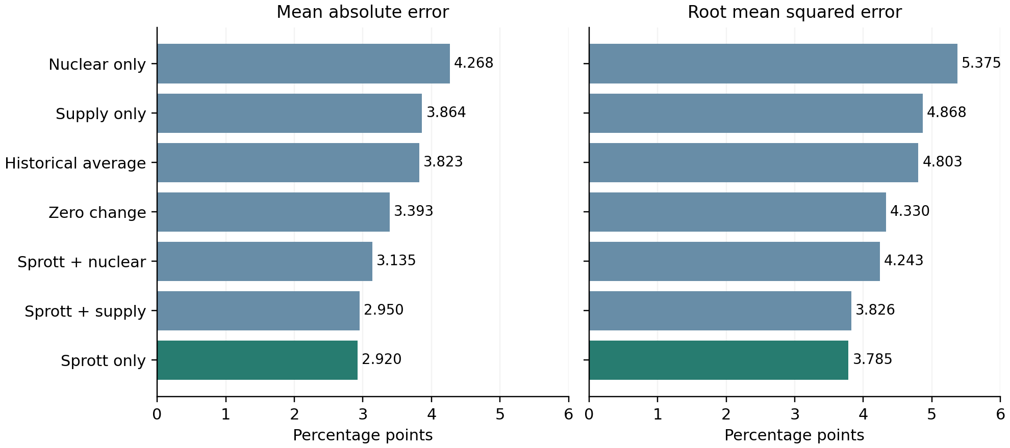
Figure 1 Mean absolute error and root mean squared error in percentage points. Both measures favour Sprott only.

Improvement relative to the benchmarks
Comparison | Change in MAE | Meaning
Sprott only versus zero change | −13.9% | Lower error
Sprott plus supply versus Sprott only | +1.0% | Slightly higher error
Sprott plus nuclear versus Sprott only | +7.4% | Higher error

The 14% rounded improvement describes error reduction. It does not measure Sprott’s causal share of uranium price movements. The small difference between Sprott only and Sprott plus supply does not establish a statistically significant difference.

7 Conclusions and the reasoning behind them
Our conclusion is based on model performance, not on whether a factor sounds economically plausible. Sprott physical purchases were the most useful measured factor during the 23-month evaluation period. Adding our supply revisions or nuclear-generation growth did not improve the Sprott-only model.

Why we retained Sprott?
It beat both simple baselines and had lower MAE and RMSE than the alternatives. That makes it the strongest measured candidate in this particular comparison. The result does not establish that purchases caused the price changes: buying may respond to prices or to shared market conditions.

Why supply and nuclear demand were not retained?
They did not improve the Sprott-only model on the agreed evaluation months. This is evidence about the collected measurements and model, not proof that supply and demand are unimportant. The numerical supply record is sparse, some cuts were preceded by warnings, and netting opposite revisions can hide offsetting news. Generation is an indirect measure of buying and excludes some countries with missing data.

Why we did not assign causal percentage weights?
Coefficient sizes depend on units, factors can overlap, and observational relationships do not identify causal contributions. Forcing the results to sum to 100% would imply more certainty than the analysis supports. We therefore report relative model usefulness and the improvement against a benchmark.
The 14% result is a reduction in prediction error. It is not the percentage of uranium price movements caused by Sprott, and it does not mean Sprott accounts for 100% of influence just because the other measured factors did not improve the model.

Suggested conclusion for your project
Over August 2024–June 2026, Sprott’s physical uranium purchases were the most useful of the three measured factors for explaining monthly uranium price changes. The Sprott-only model reduced mean absolute error by approximately 14% compared with predicting zero change. Adding production-guidance revisions or nuclear-generation growth did not improve performance. These exploratory results describe usefulness within the selected model and period, rather than causal shares of price movements.

Sources and reproducibility
IMF: supplied external-data.xlsx, External sheet, PURAN. https://data.imf.org/en/Datasets/PCPS
Sprott: official physical uranium trust page and acquisitions chart. https://sprott.com/investment-strategies/exchange-listed-products/physical-commodity-funds/uranium/
Supply: uranium_supply_announcements_2021_2026.csv. Each record retains the company announcement URL, date, production year, units and qualification.
Ember: Monthly Electricity Data, Nuclear generation in TWh. https://ember-energy.org/data/monthly-electricity-data/

